 

**FPT-APTECH COMPUTER EDUCATION**

**Ancillaries Documentation**

|  |  |
| --- | --- |
| **project-sem3-team2-t1710a** | |
| **Group Member** | Lý Quốc Trọng - D00667  Hoàng Văn Bình - D00682  Vũ Trung Thành - D00687  Vũ Thị Thu Hương - D00655 |
| **Instructor** | Nguyễn Tuân |

- Hanoi, 5/2019 -

**1.Index:**

* **Problem Definition**

A website needs to be developed where the mobile user can recharge the mobile. User can activate any services offered by the company with the help of this website. The website allows paying the Post Paid bill of the mobile, creating account. User has to register their account for using any of the services except the recharge of mobile (i.e. Top up). All the details whether registered user, daily recharge done will be viewed by the Admin.

* ***Boundaries of the System***
* ***Development Environment***

**Hardware**

* Pentium IV CPU 1.80 GHz.
* Hard disk requirement: minimum 8 GB.
* 512 Megabytes of Ram or higher.

**Software**

* Apache Tomcat 6.0.26.
* Internet Explorer 8, Firefox 3.6.
* Microsoft SQL Server 2005.
* NetBeans IDE 6.9, JDK 1.6. h
* Adobe Firework CS 5, SmartDraw VP.
* Microsoft Word 2010.
* Tortoise SVN.
* Window 2000, XP or higher.
* **Requirements and Business Flow**
* ***Customer Requirement Specification***

Our client wants the application to perform the following tasks :

* Customers can:
* Visit website
* Register or login to website.
* Recharge mobile
* View all website service and pay online
* View history order.
* Admin can manage:
* Details of customers
* Details of transactions
* Details of services
* ***Activity Diagram***

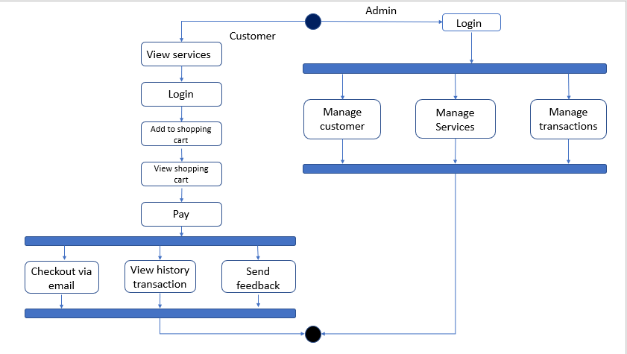

* Activity diagram “ Register”

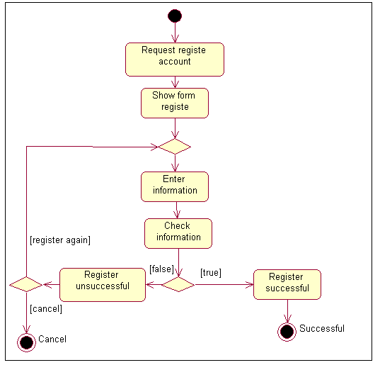

* Activity diagram “Login”

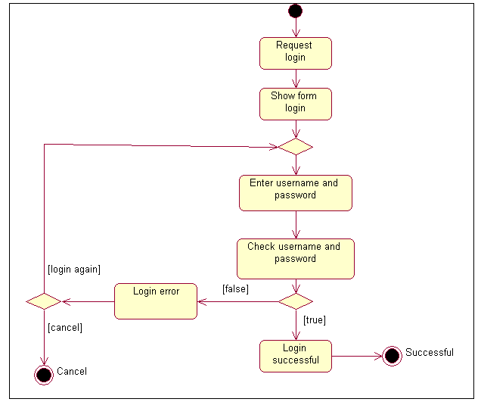

* Activity diagram “ Check out ”

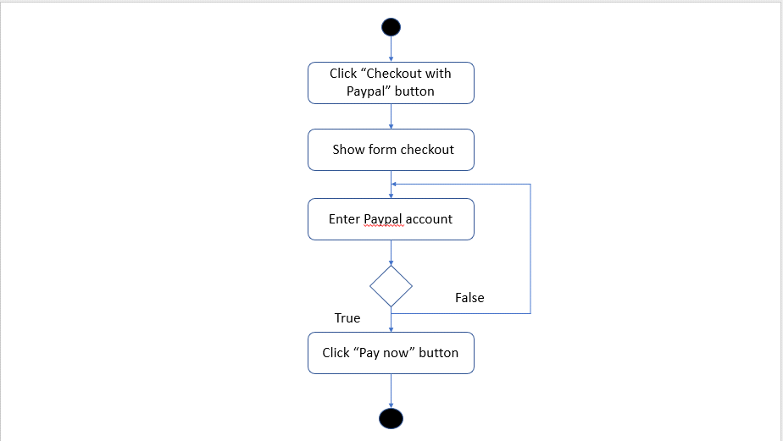

* Activity diagram “ Change password ”

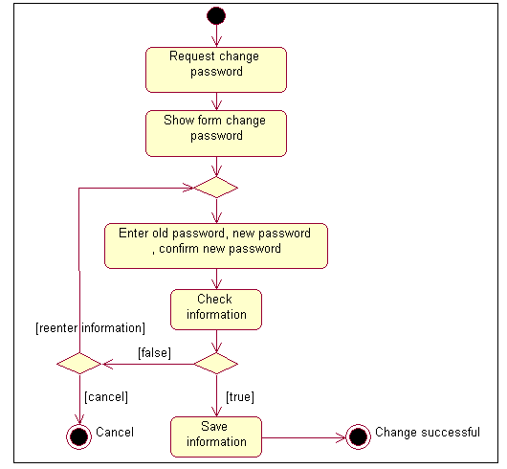

* Activity diagram “View history transaction ”

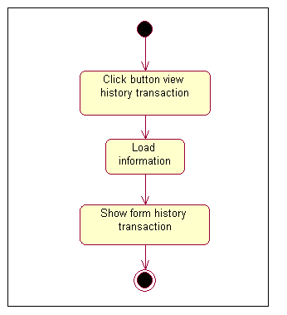

* Activity diagram “view services”

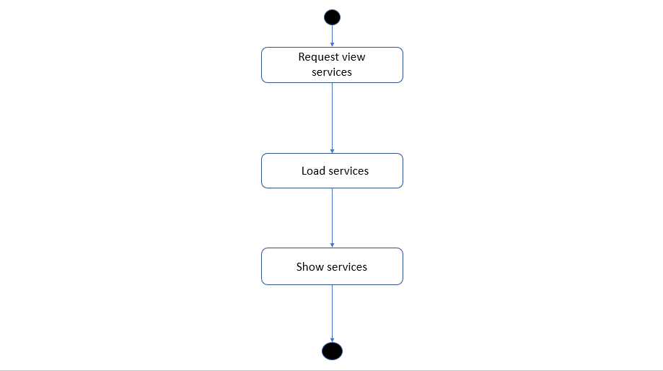

* Activity diagram “ Update shopping cart “

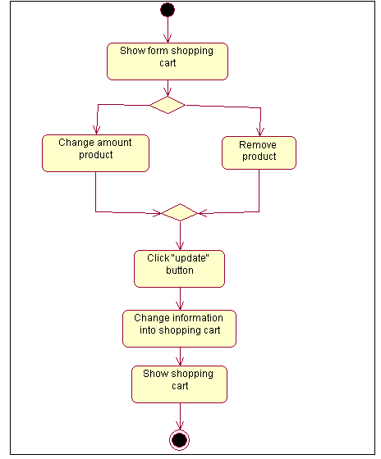

* Activity diagram “ Send feedback“

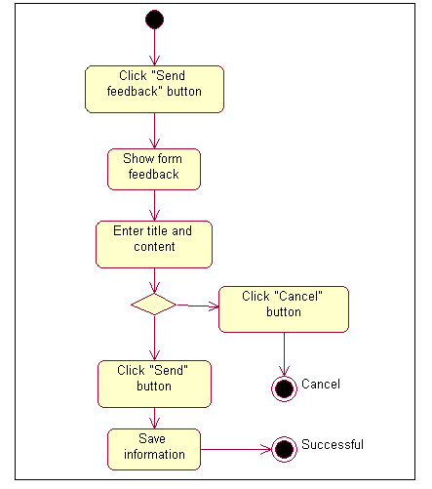

* Activity diagram “ manage service”

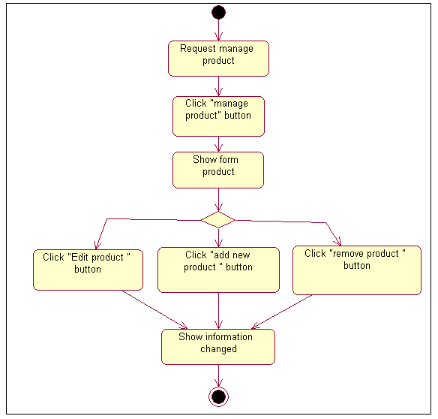

* Activity diagram “Add service “

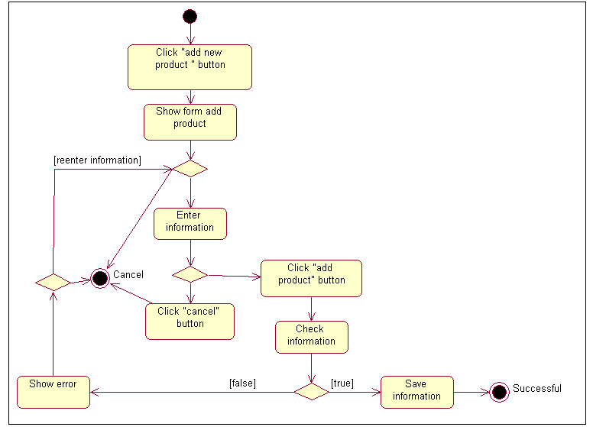

* Activity diagram “ Edit service ”

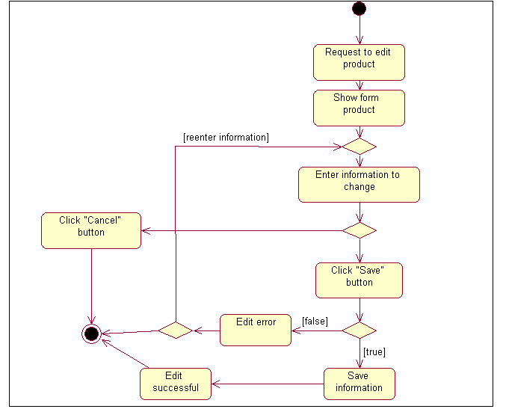

* Activity diagram “ Remove service ”

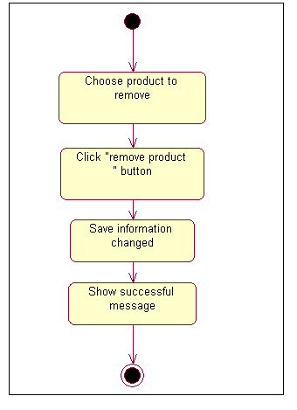

* Activity diagram “Manage customer “

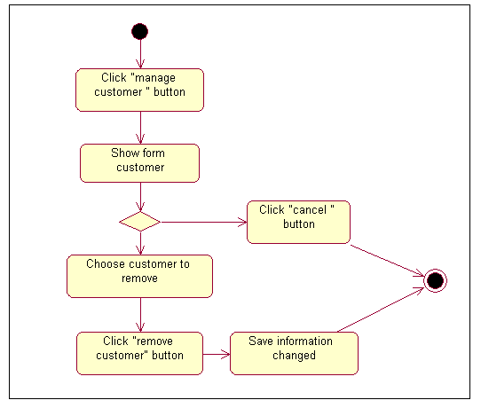

* ***Use Case Specification***

|  |  |
| --- | --- |
| **Use Case Name** | Register |
| **Actors** | Customer |
| **Brief Description** | - Use case allows the customer register to system |
| **Preconditions** | - The person has not already been registered with System |
| **Basic Flow of Events** | 1. The use case begins when customer click on “Sign up “ button in website.  2.The system show register form contains  Fields:   * Full Name. * Phone number * Password. * Email.   3. Customer enter information into form.  4.The system checks the validity of the information and send confirm email.  5. Save information of customer to database  6.System display successful register message. |
| **Alternative Flows** | A1.**Exist use name:**  If in step 4 of the basic flow customer enter an existed phone number in the database then:   * System display error message. * The use case resumes at step 3 of Basic Flow enter other phone number   A2.**Email not valid:**  If in step 4 of the basic flow customer enter an existed email in the database then:   * System display error message. * The use case resumes at step 3 of Basic Flow re-enter email address.   A3.(**Full name, password) is null:**  If in step 4 of the basic flow customer does not enter (Full name, password)then**:**   * System display error message. * The use case resumes at step 3 of Basic Flow enter requirement information. |
| **Exit Options** | - Customer click on “Close” button |
| **Special Requirements** |  |
| **Post Condition** | - Customer have a new account in system. |

|  |  |
| --- | --- |
| **Use Case Name** | **Login** |
| **Actors** | Customer, dealer-manager , admin. |
| **Brief Description** | -Actors use this use case to login to system |
| **Preconditions** |  |
| **Basic Flow of Events** | 1. Actors click on “Login “ button in website.  2.The system show” login” form contains  Fields :   * Phone number * Password.   3. Actors enter username and password into form.  4.The system checks the validity of username and password .  5.System logs the Actors into the system. |
| **Alternative Flows** | If in the step 4 Basic Flow,Customer enter invaild phone number and/or password then:  1.System display error message.  2.The use case resumes at step 3 of Basic Flow. |
| **Exit Options** | - Actors click on “Close” button |
| **Special Requirements** |  |
| **Post Condition** | - Actors login to system |

|  |  |
| --- | --- |
| **Use Case Name** | **View history transaction** |
| **Actors** | Customer |
| **Brief Description** | - Use case allows the customer view history transaction |
| **Preconditions** | -The Customer must be logged into system before this use case begins. |
| **Basic Flow of Events** | 1. The use case begins when customer click on “history“ menu in website.  2.System load transactions make by customer .  3.System display result to customer. |
| **Alternative Flows** |  |
| **Exit Options** |  |
| **Special Requirements** |  |
| **Post Condition** | - History transaction of customer is displayed. |

|  |  |
| --- | --- |
| **Use Case Name** | **View Service** |
| **Actors** | Customer |
| **Brief Description** | - Use case allows the customer view list services on the website. |
| **Preconditions** |  |
| **Basic Flow of Events** | 1. The use case begins when customer click on “Service“ menu in the website.  2.System load services in database .  3.System display result to customer. |
| **Alternative Flows** |  |
| **Exit Options** |  |
| **Special Requirements** |  |
| **Post Condition** | - list services are displayed. |

|  |  |
| --- | --- |
| **Use Case Name** | **View shopping cart.** |
| **Actors** | Customer |
| **Brief Description** | - Use case allows the customer view all services in shopping cart . |
| **Preconditions** |  |
| **Basic Flow of Events** | 1. The use case begins when customer click on “shopping cart “ icon in the menu bar.  2.System display all services in shopping cart. |
| **Alternative Flows** |  |
| **Exit Options** |  |
| **Special Requirements** |  |
| **Post Condition** | - All services in shopping cart are displayed. |

|  |  |
| --- | --- |
| **Use Case Name** | **Add to shopping cart.** |
| **Actors** | Customer |
| **Brief Description** | - Use case allows the customer add services into shopping cart . |
| **Preconditions** |  |
| **Basic Flow of Events** | 1. The use case begins when customer click on “buy service“ button when view service.  2.System get ID of service then add service to shopping cart .  3.System redirect to “view cart” page.  4.System display all service in shopping cart. |
| **Alternative Flows** |  |
| **Exit Options** |  |
| **Special Requirements** |  |
| **Post Condition** | - A service is added to shopping cart. |

|  |  |
| --- | --- |
| **Use Case Name** | **Update shopping cart.** |
| **Actors** | Customer |
| **Brief Description** | - Use case allows the customer update services into shopping cart . |
| **Preconditions** | Customer have to “view shopping cart”. |
| **Basic Flow of Events** | 1.System display shopping cart.  2.Customer change amount of service or check on “remove service”.  3. Customer click on “update” button.  4.System make change into shopping cart.  5.System redirect to “view cart” page.  6.Display all service in shopping cart. |
| **Alternative Flows** |  |
| **Exit Options** |  |
| **Special Requirements** |  |
| **Post Condition** | - shopping cart is updated. |

|  |  |
| --- | --- |
| **Use Case Name** | **Empty shopping cart.** |
| **Actors** | Customer |
| **Brief Description** | - Use case allows the customer remove all services from shopping cart . |
| **Preconditions** |  |
| **Basic Flow of Events** | 1. The use case begins when customer click on “Empty shopping cart “ button .  2.System remove all services from shopping cart .  3.System display “shopping is empty” message. |
| **Alternative Flows** |  |
| **Exit Options** |  |
| **Special Requirements** |  |
| **Post Condition** | - All service removed from shopping cart. |

|  |  |
| --- | --- |
| **Use Case Name** | **Check out** |
| **Actors** | Customer |
| **Brief Description** | - Use case allows the customer create a order . |
| **Preconditions** | -The Customer must be logged into system before this use case begins.  -lest a service added to shopping cart. |
| **Basic Flow of Events** | 1. The use case begins when customer click on “Check out “ button .  2.System display form contain:   * Address. * Phone. * Email.   3.Customer enter information into form.  4. Customer click on “Next” button.  5. System save information that customer enter.  6. System display form contain:   * Cart number. * Pin cart code.   7.Customer enter information into form.  8. Customer click on “Next” button.  9.Sytem check the validity of “Cart number” and“ Pin cart code”.  10.System transfer money from customer account to company account.  11.System save all information in shopping cart and transaction to database.  12.System display order successful message. |
| **Alternative Flows** | **Invalid Cart number or Pin cart code**  If in step 7of the basic flow customer enter a invalid Cart number or Pin cart code then:   * System display error message. * The use case resumes at step 7 of Basic Flow |
| **Exit Options** | -Customer click on “Close” button. |
| **Special Requirements** |  |
| **Post Condition** | - Customer create an order. |

|  |  |
| --- | --- |
| **Use Case Name** | **Manage mobile network provider** |
| **Actors** | admin |
| **Brief Description** | - Use case allows the admin Manage mobile network provider. |
| **Preconditions** | -The actor must be logged into system before this use case begins. |
| **Basic Flow of Events** | * This use case begin when actors click on “Network” menu. * System display list all provider and button “add”, “edit” , “delete”. * System display success message. |
| **Alternative Flows** |  |
| **Exit Options** |  |
| **Special Requirements** |  |
| **Post Condition** | - provider is added, edited or removed |

|  |  |
| --- | --- |
| **Use Case Name** | **Add mobile network provider** |
| **Actors** | Admin |
| **Brief Description** | - Use case allows the admin add new a provider. |
| **Preconditions** | -The actor must be logged into system before this use case begins. |
| **Basic Flow of Events** | 1. The use case begins when actor click on “**add new provider**” button.  2.The system show add new service form contains  Fields:   * Provider name. * Identity * Thumbnail * Country   3. Actor enter information into form.  4.Actor click on “Save” button  5.The system checks the validity of the information.  6. Save information of service to database  7.System display successful message. |
| **Alternative Flows** | **Null field:**   * If in step 5 of the basic flow customer not enter Provider name, Identity , Thumbnail , Country then:   1. System display error message.,  2. The use case resumes at step 3 of Basic Flow |
| **Exit Options** | - actor click on “Close” button |
| **Special Requirements** |  |
| **Post Condition** | - A new provider is created. |

|  |  |
| --- | --- |
| **Use Case Name** | **Edit** **mobile network provider** |
| **Actors** | Admin |
| **Brief Description** | - Use case allows the admin edit a provider |
| **Preconditions** | -The actor must be logged into system before this use case begins. |
| **Basic Flow of Events** | 1. The use case begins when actor click on “**edit**” icon.  2.The system show add new service form contains  Fields:   * Provider name. * Identity * Thumbnail * Country   3. Actor enter information into form.  4.Actor click on “Save” button  5.The system checks the validity of the information.  6. Save information of service to database  7.System display successful message. |
| **Alternative Flows** | **Null field:**   * If in step 5 of the basic flow customer not enter Provider name, Identity , Thumbnail , Country then:   1. System display error message.,  2. The use case resumes at step 3 of Basic Flow |
| **Exit Options** | - actor click on “Close” button |
| **Special Requirements** |  |
| **Post Condition** | - A provider is updated. |

|  |  |
| --- | --- |
| **Use Case Name** | **Remove mobile network provider** |
| **Actors** | admin |
| **Brief Description** | - Use case allows the admin remove a provider |
| **Preconditions** | - actor must to login into system |
| **Basic Flow of Events** | 1.The system display list provider.  2.Actor chose service want to remove then click on “delete” button.  3. System remove provider from database.  4. System display success message. |
| **Alternative Flows** | . |
| **Exit Options** | - Actor click on “Close” button |
| **Special Requirements** |  |
| **Post Condition** | - A service is removed. |

|  |  |
| --- | --- |
| **Use Case Name** | **Manage transactions** |
| **Actors** | admin |
| **Brief Description** | - Use case allows the Actors manage transaction contain: completed , pending , rejected transaction. |
| **Preconditions** | -The actor must be logged into system before this use case begins. |
| **Basic Flow of Events** | * This use case begin when actors click on “Transaction” menu. * System display list all transaction in database and buttons: completed.   - If customer not yet complete the transaction, the button must display : pending.  -If actor click “completed” , the transaction will be change to completed.  - If actor click “reject” , the transaction will be change to rejected. |
| **Alternative Flows** |  |
| **Exit Options** |  |
| **Special Requirements** |  |
| **Post Condition** | Transactions is pending, completed or rejected. |

|  |  |
| --- | --- |
| **Use Case Name** | **Manage service** |
| **Actors** | admin |
| **Brief Description** | - Use case allows the Actors manage service contain: add new ,edit , remove service. |
| **Preconditions** | -The actor must be logged into system before this use case begins. |
| **Basic Flow of Events** | * This use case begin when actors click on “Service” menu. * System display list all service in database and buttons: “add new service” ,”edit service”, ”remove service”.   -If actor click “add new service” use case “**add service**” is executed.  -If actor click “edit service” use case “**edit service**” is executed.  -If actor click “remove service” use case “**remove service**” is executed. |
| **Alternative Flows** |  |
| **Exit Options** |  |
| **Special Requirements** |  |
| **Post Condition** | - service is added, edited or removed |

|  |  |
| --- | --- |
| **Use Case Name** | A**dd service** |
| **Actors** | Admin |
| **Brief Description** | - Use case allows the admin add new a service. |
| **Preconditions** | -The actor must be logged into system before this use case begins. |
| **Basic Flow of Events** | 1. The use case begins when actor click on “A**dd**” button.  2.The system show add new service form contains  Fields:   * Service name. * Price * Type * Description. * Provider * Date start * Date expired   3. Actor enter information into form.  4.Actor click on “Add” button  5.The system checks the validity of the information.  6. Save information of service to database  7.System display successful message. |
| **Alternative Flows** | **Null field:**   * If in step 5 of the basic flow customer not enter service name, Price, Type, Description, Provider, Date start and Date expired then:   1. System display error message.,  2. The use case resumes at step 3 of Basic Flow |
| **Exit Options** | - actor click on “Close” button |
| **Special Requirements** |  |
| **Post Condition** | - A new service is created. |

|  |  |
| --- | --- |
| **Use Case Name** | **Edit service** |
| **Actors** | Admin |
| **Brief Description** | - Use case allows the admin Edit service. |
| **Preconditions** | -The actor must be logged into system before this use case begins. |
| **Basic Flow of Events** | 1. The use case begins when actor click on “**Edit**” icon.  2. The system load information of service into form contains:   * Service name. * Price * Type * Description. * Provider * Date start * Date expired.   3. actor change information in form.  4.Actor click on “Update” button  5.The system checks the validity of the information.  6. Save information of service to database  7.System display successful message. |
| **Alternative Flows** | **Null field:**   * If in step 5 of the basic flow customer not enter service name, Price, Type, Description, Provider, Date start and Date expired then:   1. System display error message.,  2. The use case resumes at step 3 of Basic Flow |
| **Exit Options** | - actor click on “Close” button |
| **Special Requirements** |  |
| **Post Condition** | - The service is updated. |

|  |  |
| --- | --- |
| **Use Case Name** | **Remove service** |
| **Actors** | admin |
| **Brief Description** | - Use case allows the admin remove a service. |
| **Preconditions** | - actor must to login into system |
| **Basic Flow of Events** | 1.The system display list service.  2.Actor chose service want to remove then click on “remove” icon.  3. System remove service from database.  4. System display success message. |
| **Alternative Flows** | . |
| **Exit Options** | - Actor click on “Close” button |
| **Special Requirements** |  |
| **Post Condition** | - A service is removed. |

|  |  |
| --- | --- |
| **Use Case Name** | **Manage customer** |
| **Actors** | admin |
| **Brief Description** | - Use case allows the Actors manage customer contain: remove customer. |
| **Preconditions** | -The actor must be logged into system before this use case begins. |
| **Basic Flow of Events** | * This use case begin when actors click on “manage customer” menu. * System display list all customer in database and button “remove customer”. * Actor chose customer want to remove then click on “Remove” button. * System remove customer from database. * System display success message. |
| **Alternative Flows** |  |
| **Exit Options** |  |
| **Special Requirements** |  |
| **Post Condition** | - A customer is removed |

|  |  |
| --- | --- |
| **Use Case Name** | **View feedback** |
| **Actors** | admin |
| **Brief Description** | - Use case allows the admin view feedback of customer. |
| **Preconditions** | -The actor must be logged into system before this use case begins. |
| **Basic Flow of Events** | * This use case begin when actors click on “view feedback” menu. * System display list all feedback. * Actor choose feedback want to view detail or remove feedback * System display success message. |
| **Alternative Flows** |  |
| **Exit Options** |  |
| **Special Requirements** |  |
| **Post Condition** |  |

**3.8.Accept Event Register**

* ***Other Diagrams <Optional>***

* **Design**
* ***System Architecture***

Website bases on MVC (Model-View-Controller) architecture

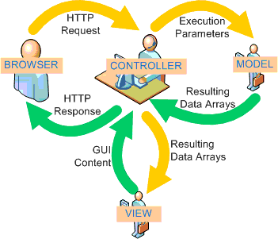

Web-Based Distributed MVC Architecture of the Project

* ***Sequence Diagram :***
* Sequence diagram “ Register ”

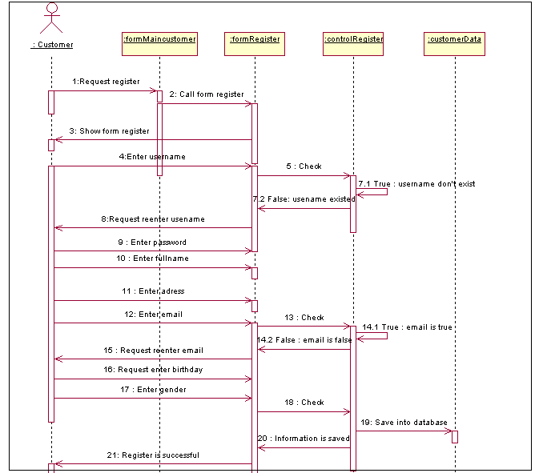

* Sequence diagram “Update profile “

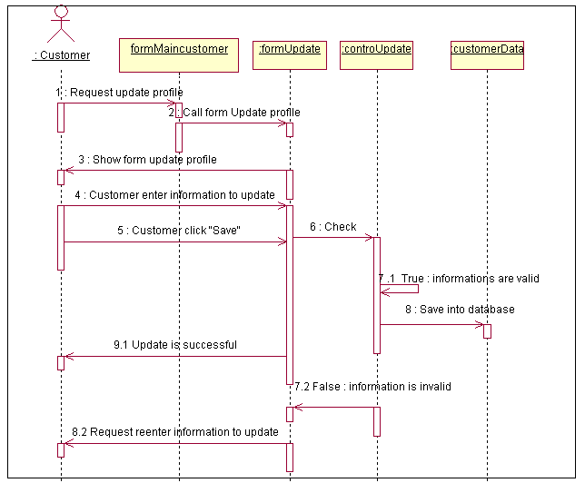

* Sequence diagram “Login”

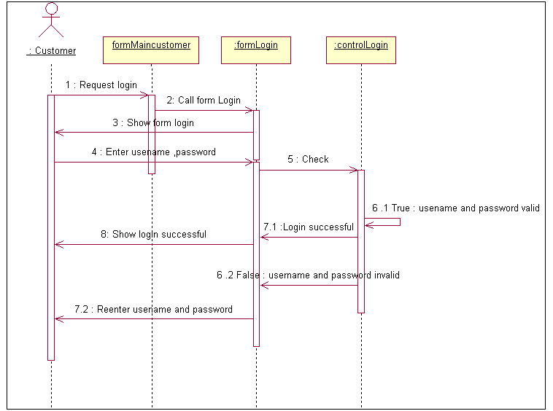

* Sequence diagram “Change password “

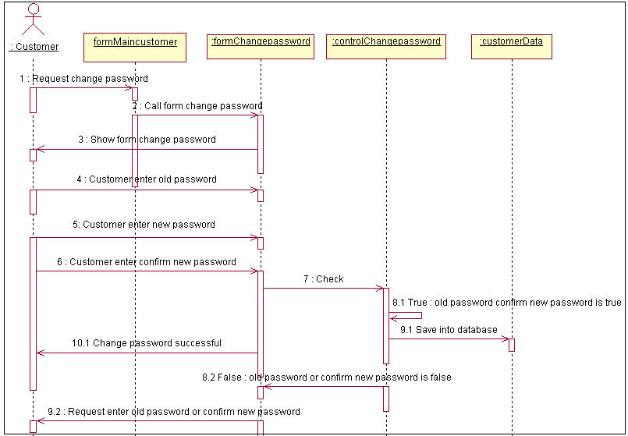

* Sequence diagram “Add to shopping cart “

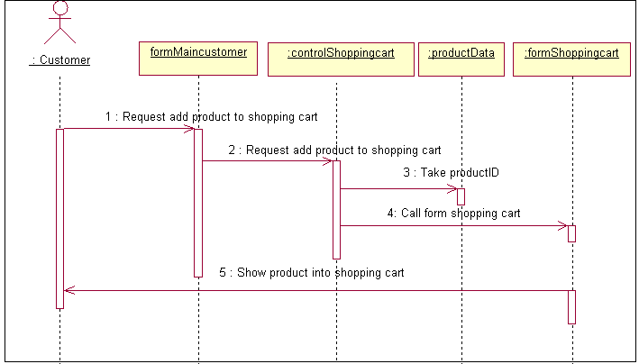

* Sequence diagram “Update shopping cart”

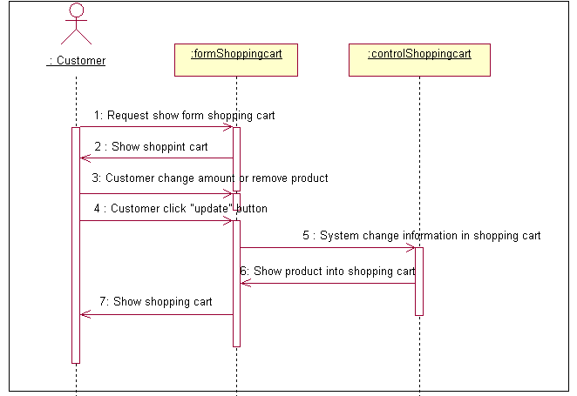

* Sequence diagram “Empty shopping cart”

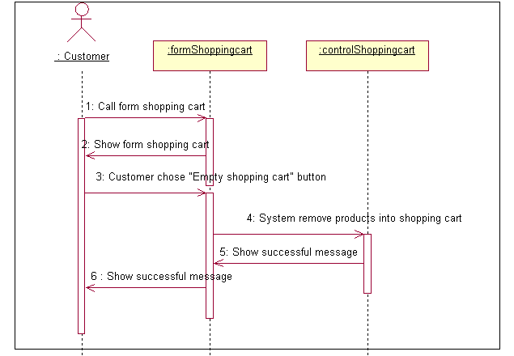

* Sequence diagram “Check out “

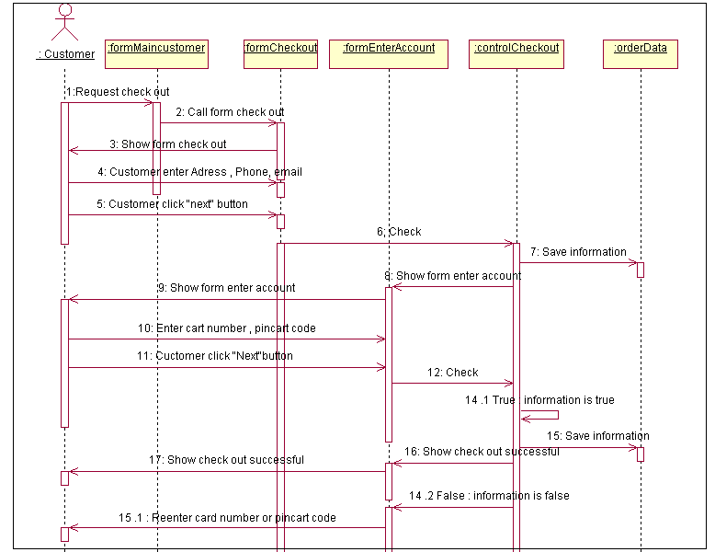

* Sequence diagram “ Manage service “

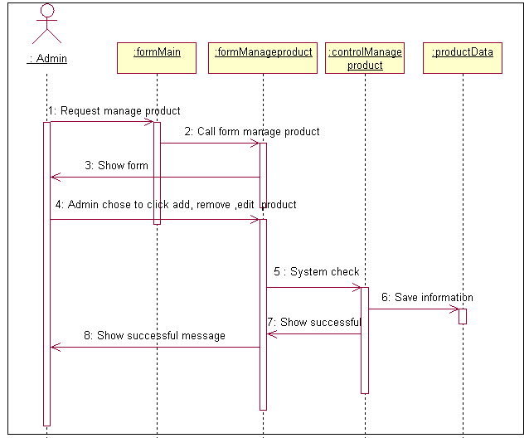

* Sequence diagram “Add service “

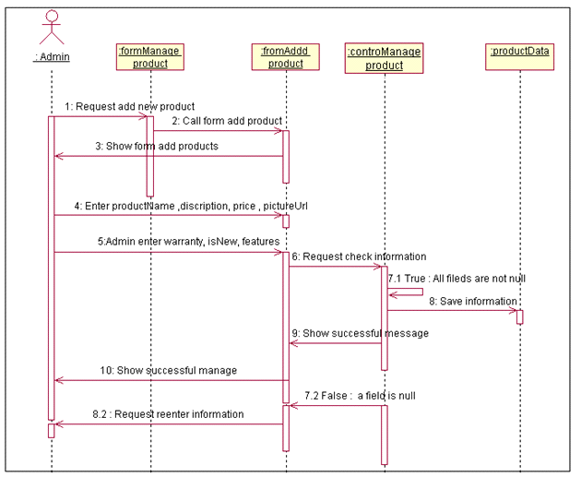

* Sequence diagram “Edit service “

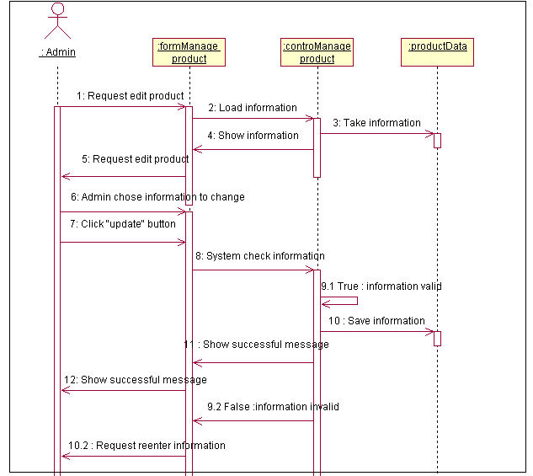

* Sequence diagram “ Remove service“

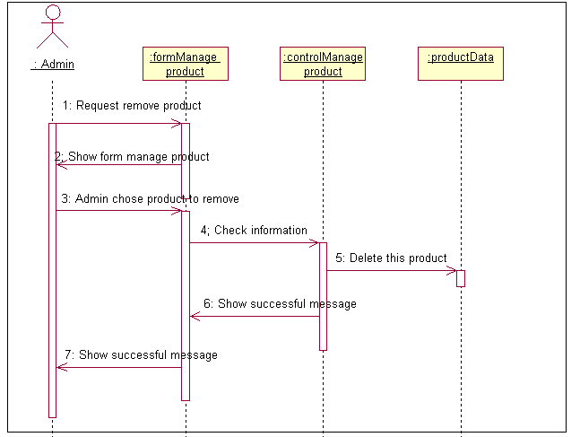

* Sequence diagram ”Manage customers “

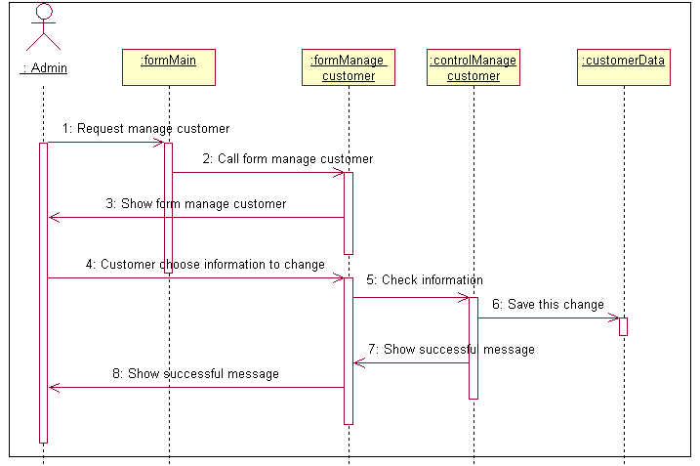

* Sequence diagram “ View feedback”

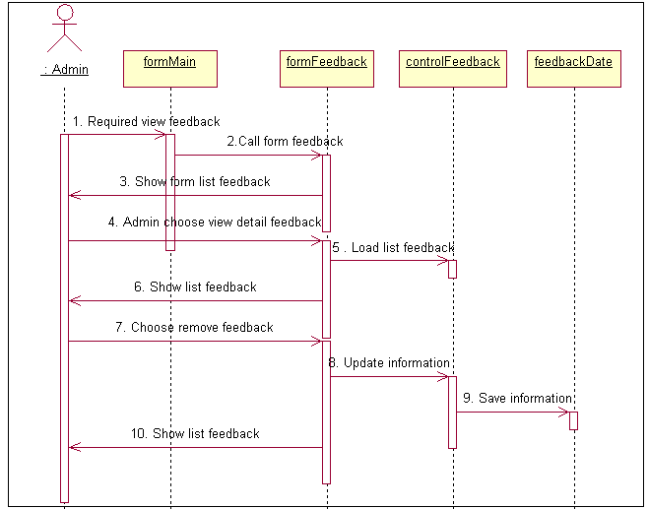

***Entity Relationship Diagram***

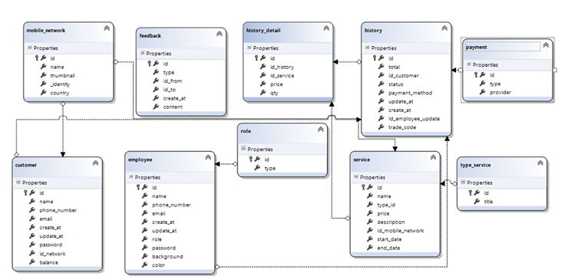

* ***Database Design***

|  |  |  |  |  |
| --- | --- | --- | --- | --- |
| **Table : mobile_network** | | | | |
| **Field Name** | **Data Type** | **Null** | **Key** | **Description** |
| id | Int | No | PK | ID of mobile­_network |
| name | varchar(255) | No |  | Name of mobile­_network |
| thumbnail | varchar(255) | No |  | logo of mobile­_network |
| _identity | varchar(255) | No |  | identity of mobile­_network |
| country | varchar(255) | No |  | country of mobile­_network |

|  |  |  |  |  |
| --- | --- | --- | --- | --- |
| **Table : customers** | | | | |
| **Field Name** | **Data Type** | **Null** | **Key** | **Description** |
| id | Int | No | PK | ID of customer |
| name | varchar(255) | No |  | name of customer |
| phone number | varchar(255) | No |  | customer's phone number |
| email | varchar(255) | No |  | email of customer |
| create_at | varchar(255) | No |  | time create account |
| update_at | varchar(255) | No |  | time update account |
| password | varchar(255) | No |  | password of customer |
| id_network | Int | No | FK | id of mobile_network |
| balance | float | No |  | balance of customer |

|  |  |  |  |  |
| --- | --- | --- | --- | --- |
| **Table : history_detail** | | | | |
| **Field Name** | **Data Type** | **Null** | **Key** | **Description** |
| id | Int | No | PK | ID of history_detail |
| id_history | Int | No | FK | id of history |
| id_service | Int | No | FK | id of service |
| price | float | No |  | price of service |
| qty | Int | No |  | quantity of service |

|  |  |  |  |  |
| --- | --- | --- | --- | --- |
| **Table : service** | | | | |
| **Field Name** | **Data Type** | **Null** | **Key** | **Description** |
| id | Int | No | PK | ID of service |
| name | varchar(255) | No |  | Name of service |
| type_id | Int | No | FK | id of type_service |
| price | float | No |  | price of service |
| description | varchar(255) | No |  | description of service |
| id_mobile_network | Int | No | FK | Id of mobile_network |

|  |  |  |  |  |  |
| --- | --- | --- | --- | --- | --- |
| **Table : history** | | | | | |
| **Field Name** | | **Data Type** | **Null** | **Key** | **Description** |
| id | | Int | No | PK | ID of history |
| total | | float | No |  | total price of transaction |
| id_customer | | Int | No | FK | Id of customer |
| status | | Int | No |  | status of transaction |
| payment_method | | Int | No |  | Payment method |
| create_at | | varchar(255) | No |  | time created |
| ­update_at | | varchar(255) | No |  | time updated |
| id_employee_update | Int | | No | FK | id of employee |
| toDate | varchar(255) | | No |  | trade code of transaction |

|  |  |  |  |  |
| --- | --- | --- | --- | --- |
| **Table : payment** | | | | |
| **Field Name** | **Data Type** | **Null** | **Key** | **Description** |
| id | Int | No | PK | ID of payment |
| type | varchar(255) | No |  | type of transaction |
| provider | varchar(255) | No |  | name of provider |

|  |  |  |  |  |
| --- | --- | --- | --- | --- |
| **Table :employee** | | | | |
| **Field Name** | **Data Type** | **Null** | **Key** | **Description** |
| id | Int | No | PK | ID of employee |
| name | varchar(255) | No |  | Name of employee |
| phone number | varchar(11) | No |  | employee's phone number |
| email | varchar(255) | No |  | employee's email |
| create_at | varchar(255) | No |  | time created |
| update_at | varchar(255) | No |  | time update |
| role | Int | No | FK | id of role |
| password | varchar(255) | No |  | password of employee |
| background | varchar(255) | No |  | employee avatar |
| color | varchar(255) | No |  | avatar background color |

|  |  |  |  |  |
| --- | --- | --- | --- | --- |
| **Table : role** | | | | |
| **Field Name** | **Data Type** | **Null** | **Key** | **Description** |
| id | Int | No | PK | id of role |
| type | varchar(255) | No |  | type of employee |

|  |  |  |  |  |
| --- | --- | --- | --- | --- |
| **Table : type_service** | | | | |
| **Field Name** | **Data Type** | **Null** | **Key** | **Description** |
| id | Int | No | PK | id of type_service |
| title | varchar(255) | No |  | Title of type_service |

|  |  |  |  |  |
| --- | --- | --- | --- | --- |
| **Table : feedback** | | | | |
| **Field Name** | **Data Type** | **Null** | **Key** | **Description** |
| id | Int | No | PK | id of feedback |
| type | string | No |  | Type of record |
| id_from | Int | No |  | Id of sender |
| Id_to | Int | No |  | Id of receiver |
| create_at | String(255) | No |  | Time create |
| content | text | No |  | Content of feedback |

* ***Check List of Validation***

|  |  |
| --- | --- |
| **Checklist Option** | **Validated** |
| Can a new user who gets registered, enter the web site after logging in? | Yes |
| Do all the links navigate to the correct web page? | Yes |
| Does the web site’s functionality resolve the client problem and satisfy his need? | Yes |
| Has the hardware and software been correctly chosen? | yes |

* ***Submission Checklist***

|  |  |  |  |  |  |
| --- | --- | --- | --- | --- | --- |
| **Sr.No** | **Particulars** | **Yes** | **No** | **NA** | **Comments** |
| 1 | Are the users able to enter the web site after validation is performed on the UserID and password? | Yes |  |  |  |
| 2 | Are the users able to enter the web site after getting registed? | Yes |  |  |  |
| 3 | Do all the web page contents are devoid of spelling mistakes? | Yes |  |  |  |
| 4 | Is the user able to post entry to the web site | Yes |  |  |  |
| 5 | Do all user and visitor able to view forum | Yes |  |  |  |
| 6 | Admin able manage activity of forum | Yes |  |  |  |
| 7 | Is the web site user- friendly | Yes |  |  |  |

* **Screenshots**

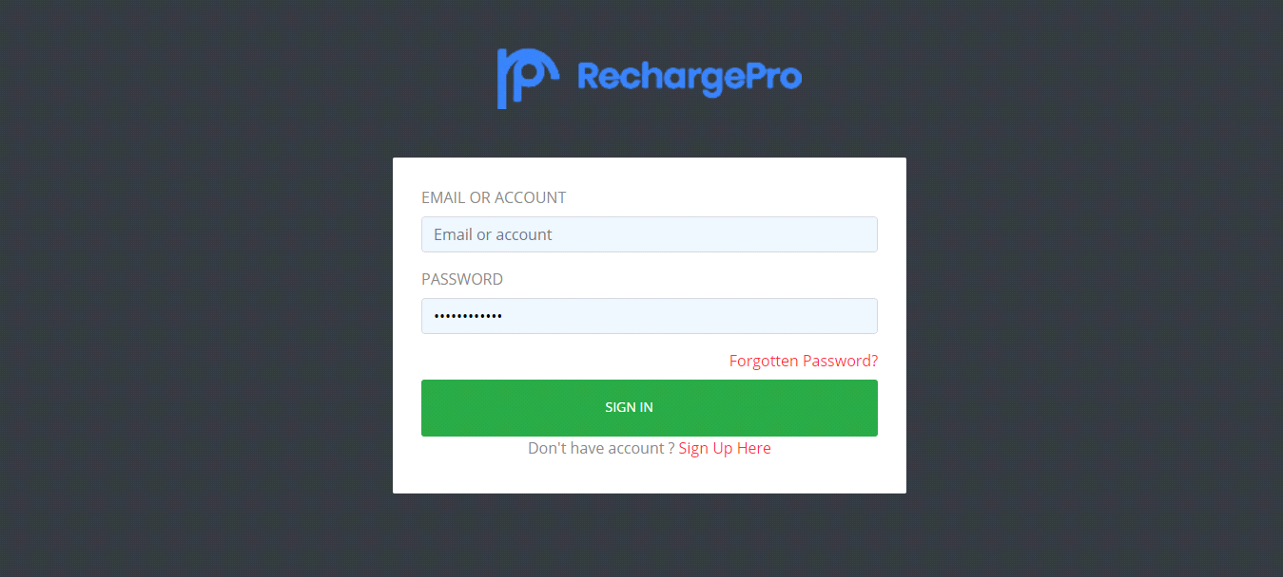

**Admin login**

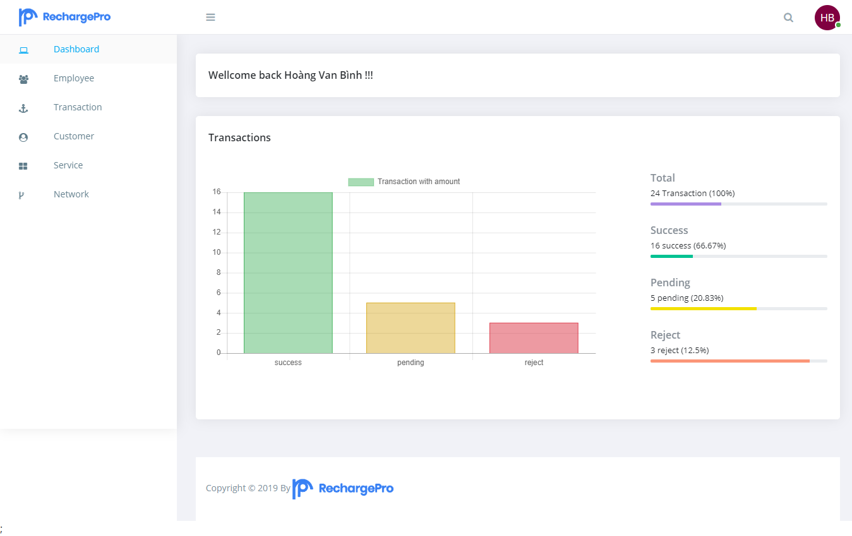

**Admin page**

**Manage service**

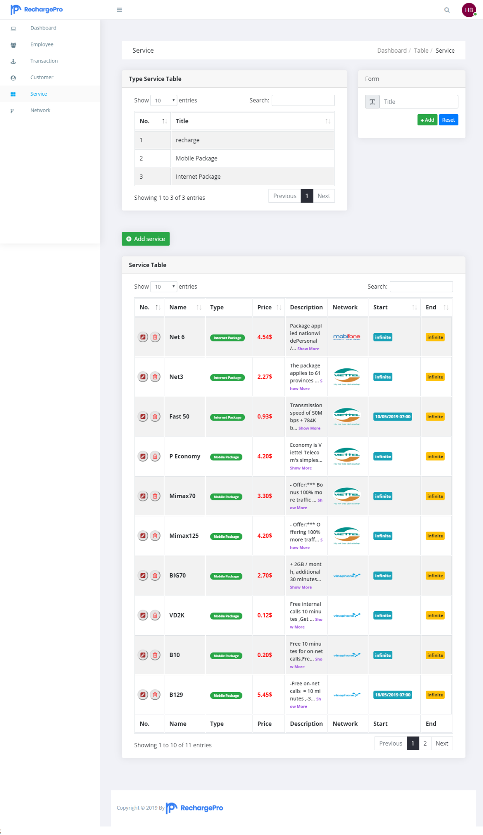

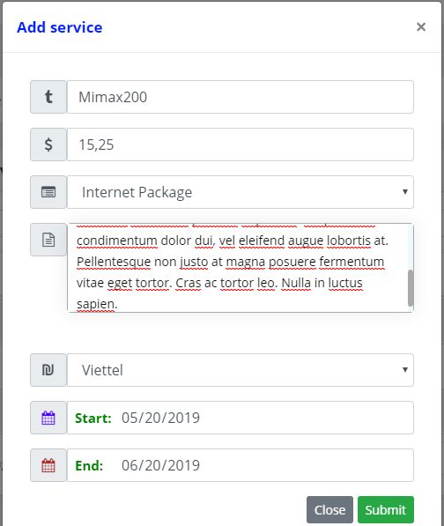

**Add new service**

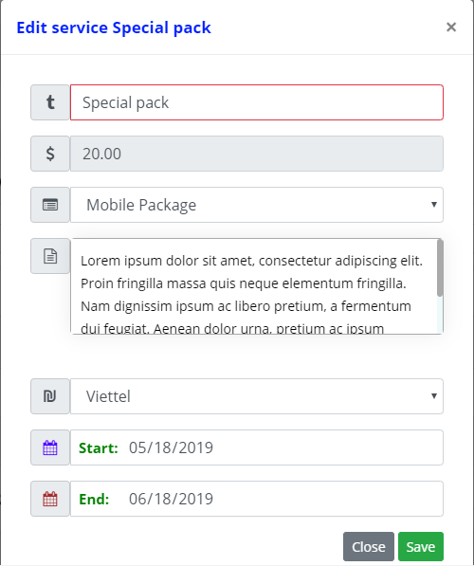

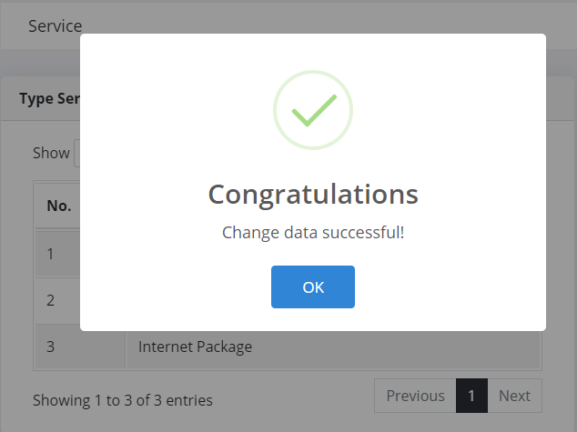

**Edit Service**

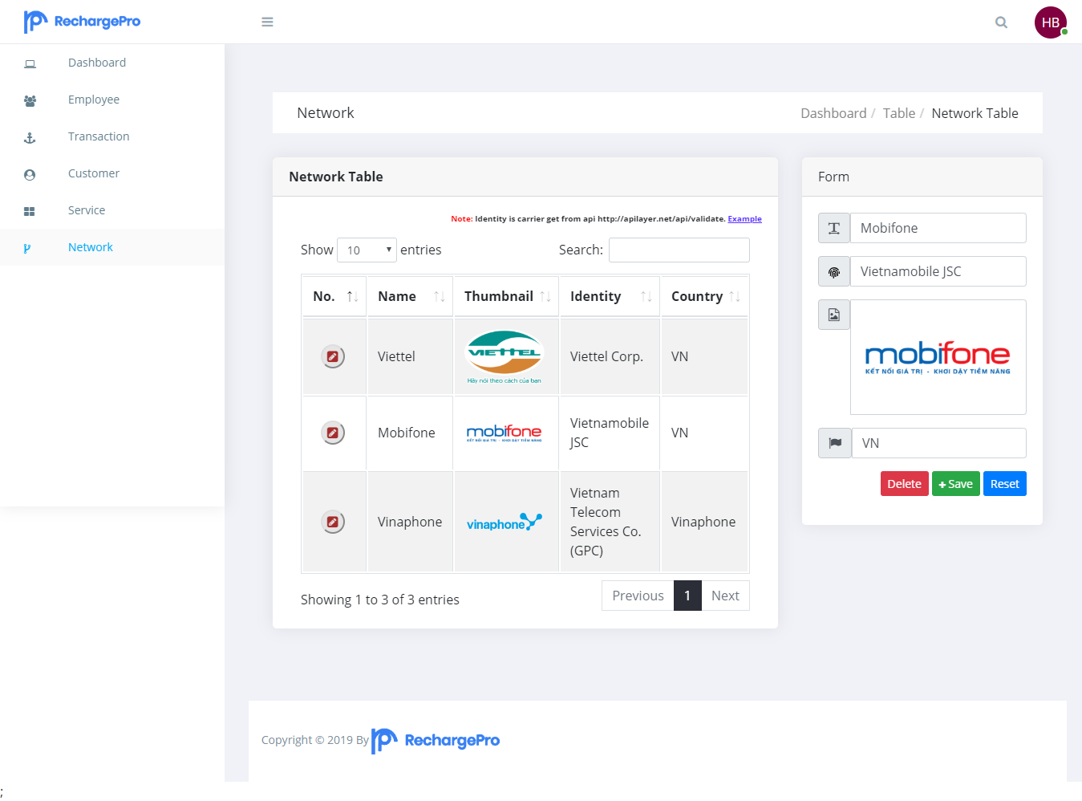

**Manage mobile network**

**Edit & delete mobile network**

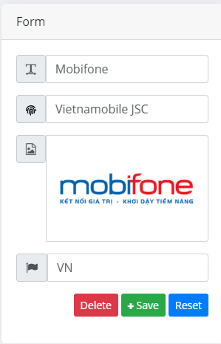

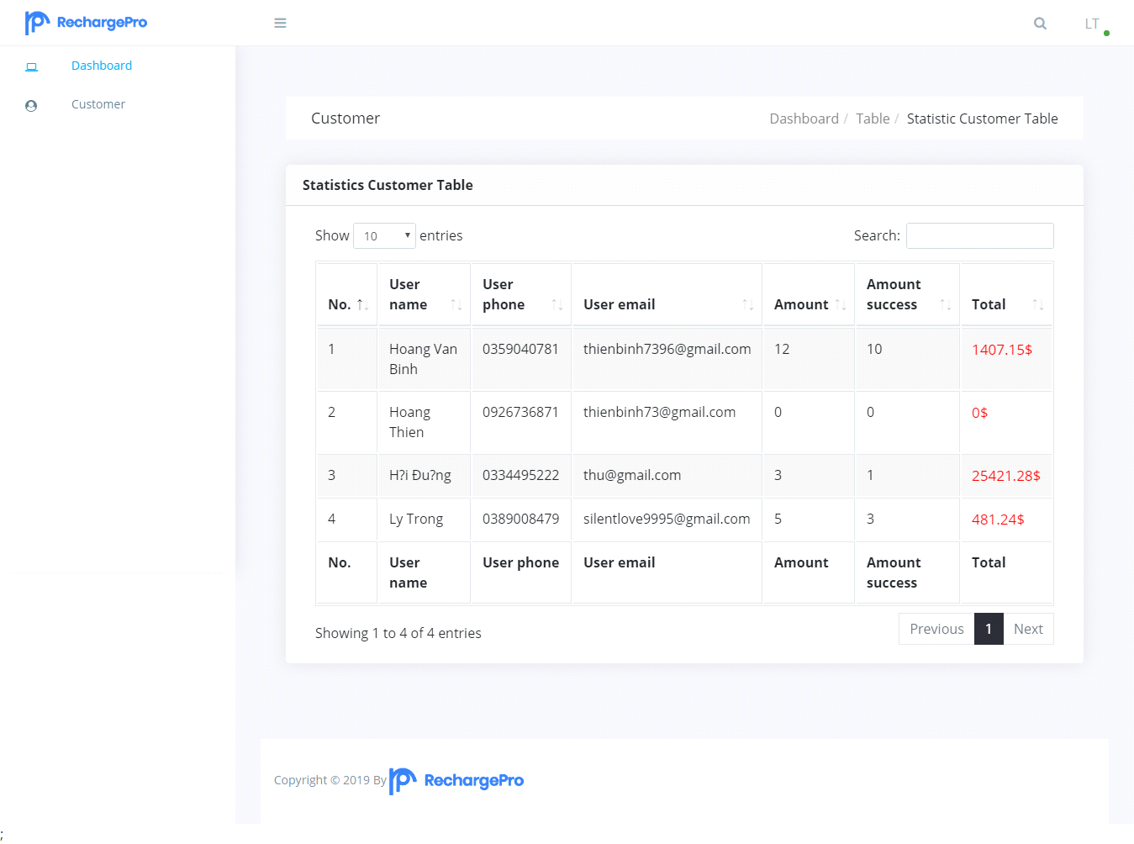

**List Customer**

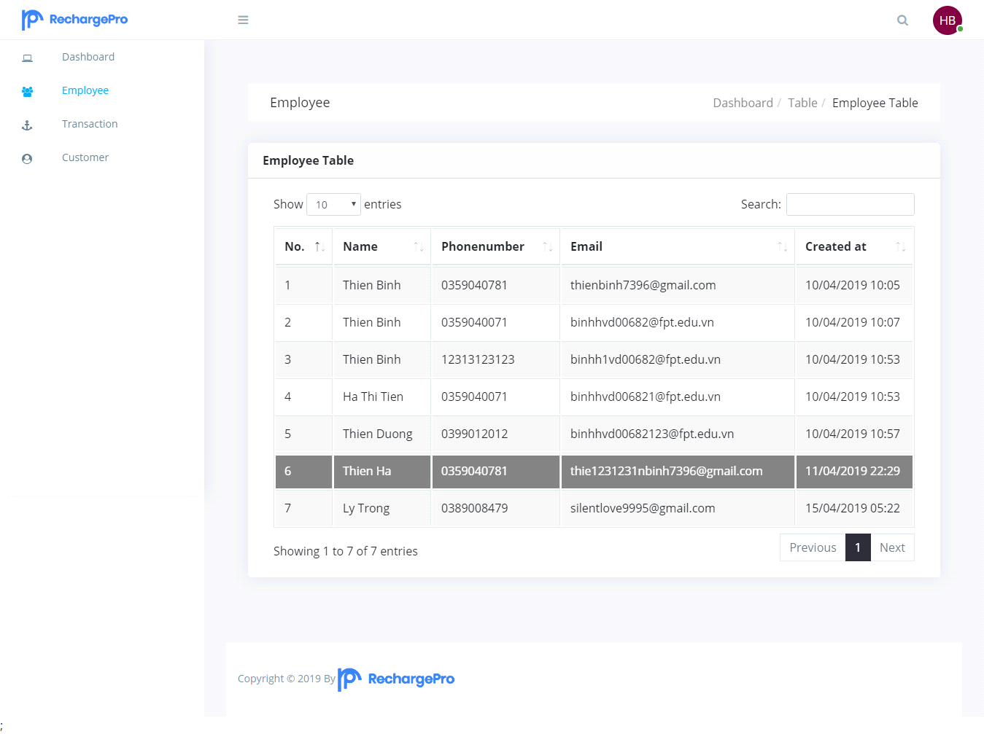

**Employee details**

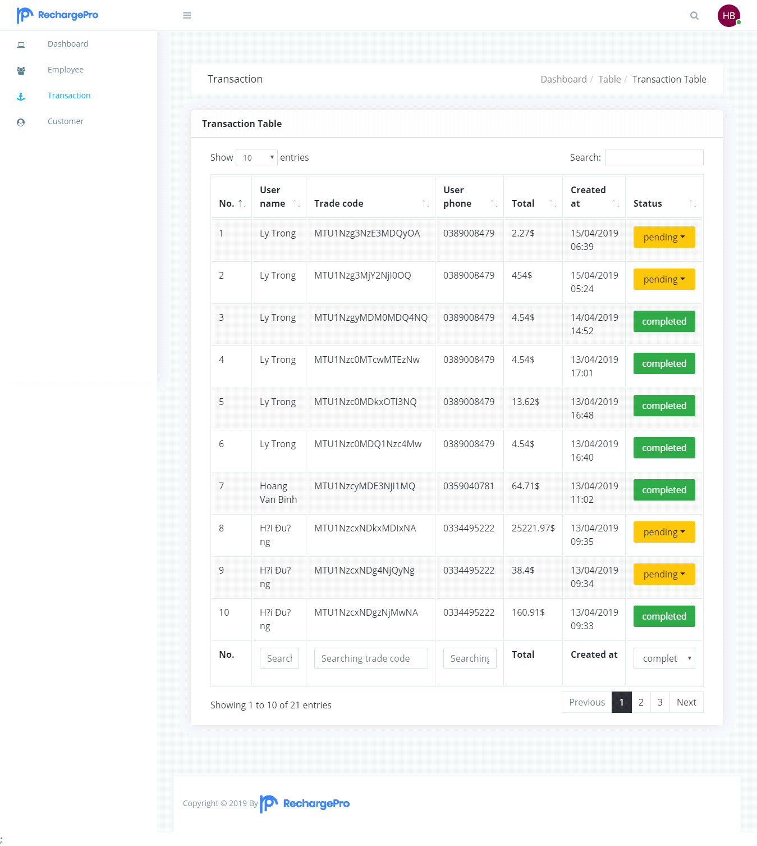

**Manage transaction**

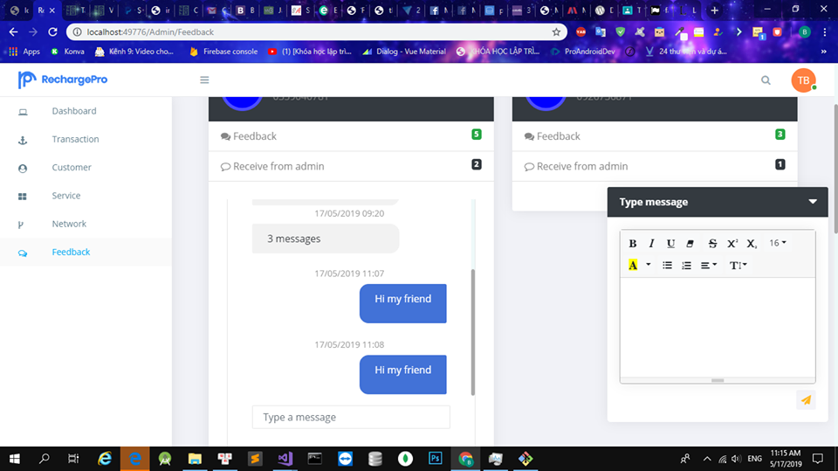

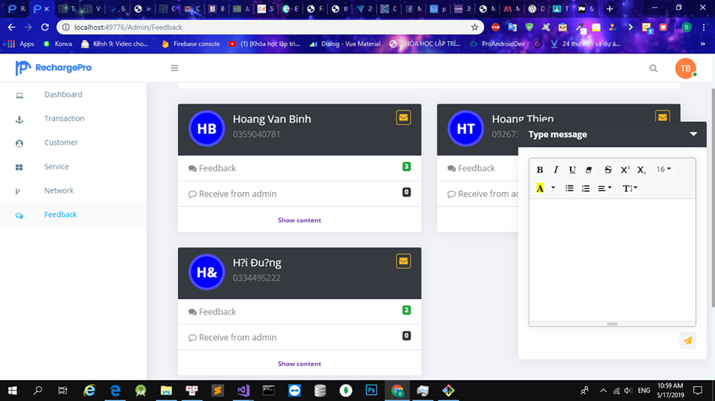

**Manage feedback**

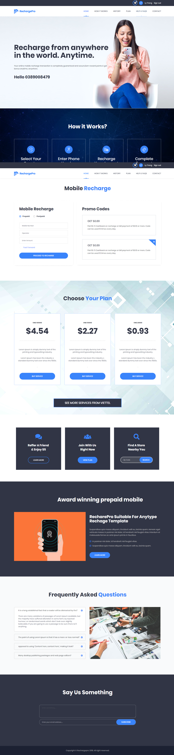

**Customer Home page**

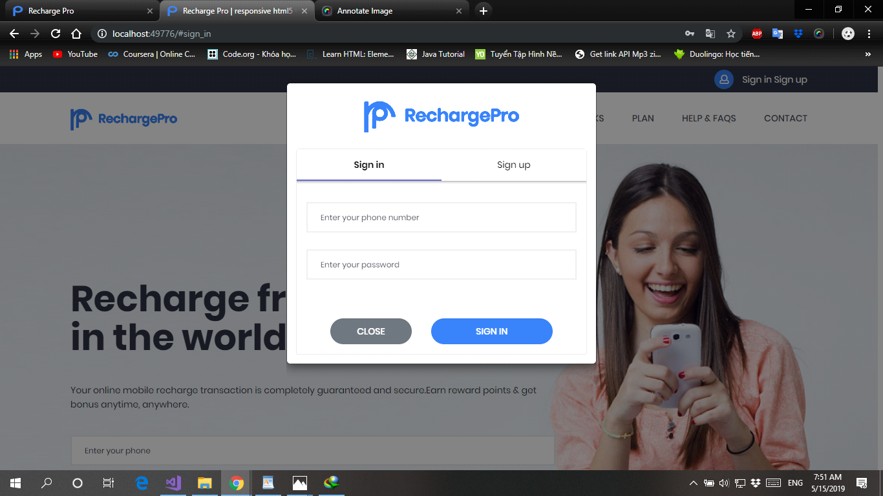

**Customer login**

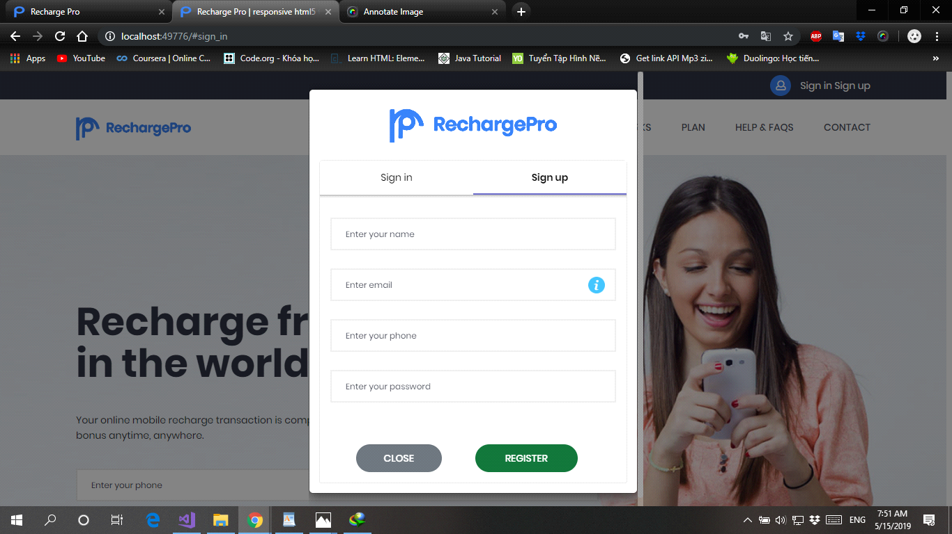

**Customer register**

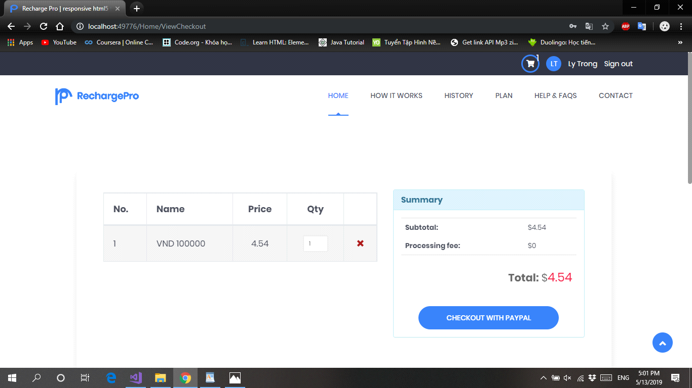

**Shopping cart**

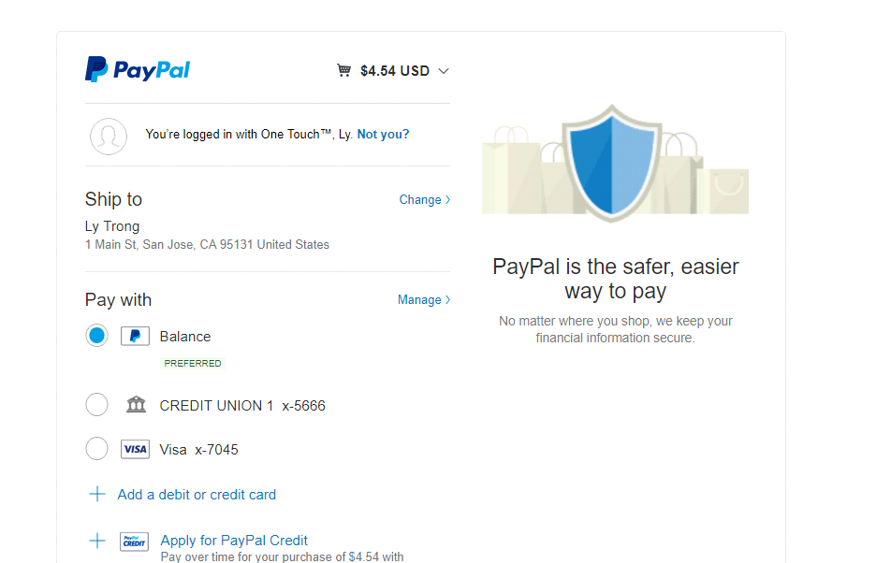

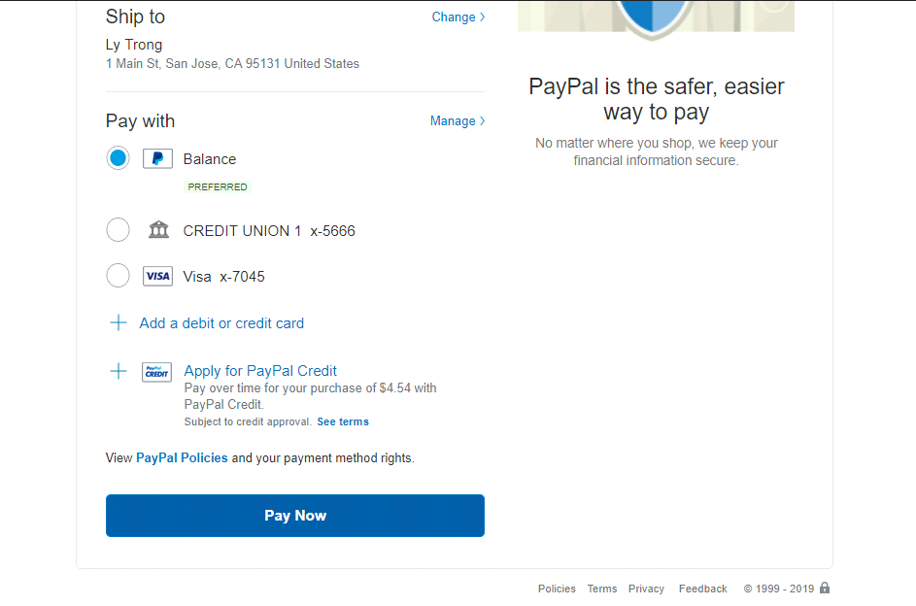

**Customer checkout**

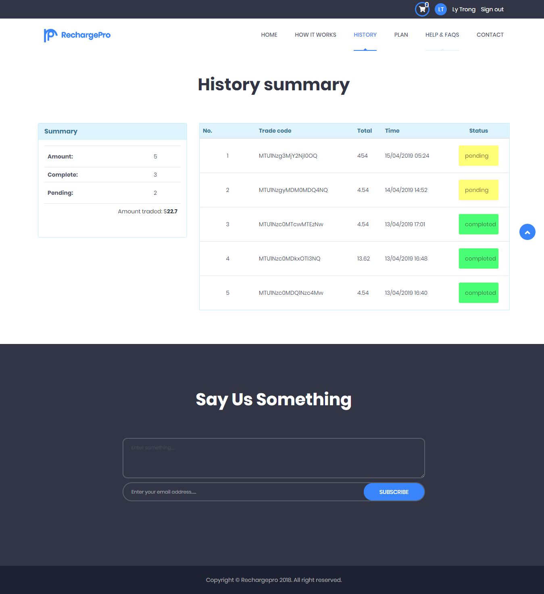

**Customer transaction history**

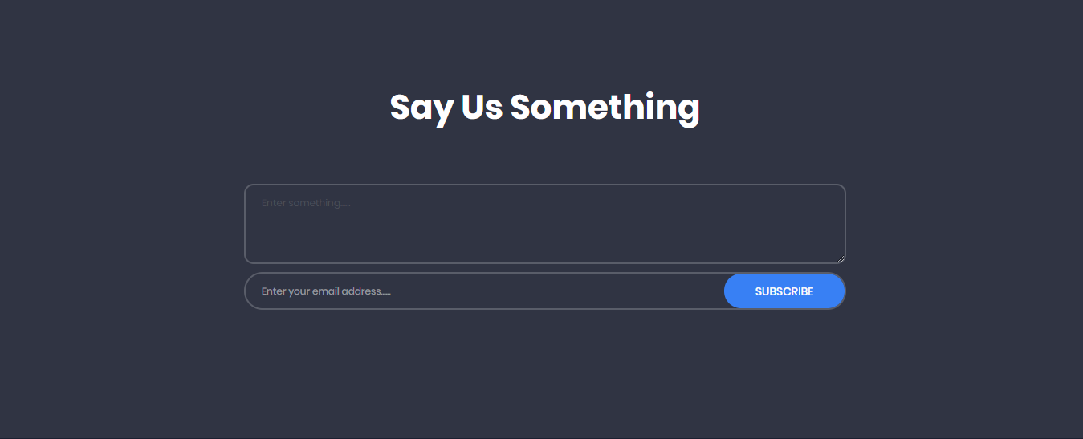

**Customer feedback**